KEEVIL PARISH COUNCIL
MINUTES OF THE EXTRAORDINARY MEETING OF THE PARISH COUNCIL of
Monday 21 July 2025 in the village hall
Present: Cllrs Pat Tucker (chair), Rob Banfield, Rodney Meatyard, Graham Miller, Caroline Munday; plus (from item 31) Cllr Robert Morgan.
In Attendance: Sarah Dow (Parish Clerk), and 4 members of the public.
Notes of Public Consultation: A resident asked about the Council’s communication regarding an ongoing planning matter, to which Cllr Munday explained she was taking steps to contact residents.
MINUTE ITEMS
25/26 - 29 Apologies for absence: were noted from Cllr Simon Gough.
25/26 - 30 Declaration of Interest: there were none.
25/26 - 31 Co-option to Post Election Vacancy
- In accordance with Council policy, Mr Morgan was invited to speak, and responded to questions from Members. Proposed and seconded by Cllrs Munday and Banfield and voting by show of hands, it was resolved unanimously to co-opt Mr Robert Morgan to the Office of Member of Keevil Parish Council.
- The Declaration of Office duly signed [LGA1972s.83], the Chair invited Cllr Morgan to join the meeting. The Clerk reminded all new Councillors to complete their Register of Interests with Wiltshire Council.
- The Chair noted she would be on holiday in September so the Vice Chair role would be considered in November, being the earliest time a full council was expected. Portfolio roles were discussed, with Cllrs Miller and Morgan joining the Chair on the Personnel Committee, Cllr Morgan sharing School liaison and PROW, and Cllr Miller sharing Planning. See Appendix.
25/26 – 32 Planning Matters
- Applications: To discuss the following application (to be resolved at the Ordinary Meeting 1st September):
PL/2025/05419: The Old Barn, Keevil - Change of use/conversion to a self-build dwelling, construction of open fronted car port, EV charging point, log store and associated works.
Further to 25/26-23(i) and agreement with applicant and Case Officer for the Council’s formal response to be submitted on 2nd September, Members were able to have an informed discussion of the application with the applicants available to respond to questions. Members sought clarification on a number of areas relating to WC Core Policy and the current Local Plan, including community, infill and village policy limits, re-use of buildings, access & visibility, impact on bats and ecology.
The applicant resides in the local area and intends to be completely self-sufficient with affordable off-grid means of living. A letting arrangement had been considered but owing to a perceived risk of abuse, a residential conversion was now their preferred option. Steps have already been taken to mitigate the impact on bats, which have reportedly increased, and owl boxes placed on the property are lived in. The owners visit the site on a weekly basis.
There being no other comments from members of the public, the Chair thanked the applicants for their help, and confirmed the Council’s Consultee Response will be decided on 1st September.
- PL/2025/05845 Land at Manor Farm - Erection of one self-build dwelling and associated works.
The Clerk has emailed several times to ask for an extension so that the application can be considered on 1st September, however, the Case Officer has changed to Russell Brown and as yet there has been no reply. The Clerk will continue to pursue but noted in the absence of a positive response it would be necessary to meet again on the interim date of 4th August.
- Submission of PC Consultee responses: The following submissions since the last meeting were noted:
NO OBJECTION subject to condition: Proposed single storey rear extension & associated internal alterations at Baldham Mill PL/2025/04332
- Other ongoing planning matters: The submission of a formal enforcement complaint relating to Big Dog Farm was noted, reference ENF/2025/00598. Cllr Munday reported having tried to visit the residents of 39 Main Street without success, she would continue to pursue.

There being no further business the meeting closed at 21:12
The next Ordinary Meeting of the Parish Council is Monday 1st September 2025, at 7pm in the village hall, starting with extended Public Forum presentation by the Banfield Recreation Ground Residents Group.

Signed………………………………………………….……………………….

Dated………………………………………………………….………………..

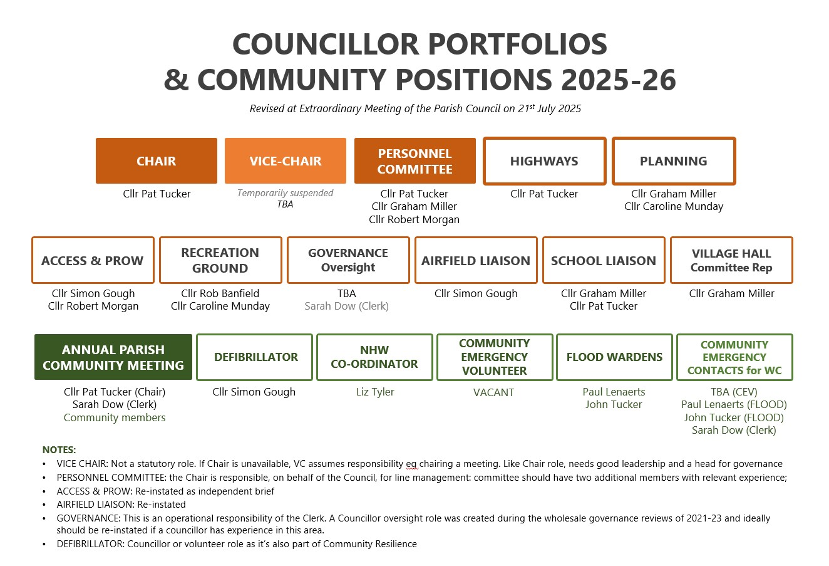
Appendix to 25/26-31(iii)

