KEEVIL PARISH COUNCIL
MINUTES OF THE ORDINARY MEETING OF THE PARISH COUNCIL of
Monday 03 March 2025 in the village hall
Present: Cllrs Alex Goodwin (chair), Paul Adams, Francis Banfield, Rob Kevan, Rodney Meatyard, Pat Tucker, & Geoff West.
In Attendance: Sarah Dow (Parish Clerk), 15 members of the public including Paul Lenaerts & John Tucker as Volunteer Flood Wardens, plus Caroline Noonan, Chair of Friends of Keevil School (FOKS) and Cllr Jonathon Seed, Wiltshire Council (WC), who attended part of the meeting.
Notes of Public Consultation:
A resident expressed gratitude to Cllr Pat Tucker and Cllr Jonathon Seed for their speed of response and assistance in dealing with the potholes in Martins Lane, which were resolved within a week of being reported – a comment echoed by the Chair and other Councillors. They also commented on the disappointing number of responses to the Residents Survey of the Recreation Ground.
Referring to the point on Pyatts Corner where the footpath at the far end of the Recreation Ground meets the road, a resident commented on pedestrian safety and asked the Parish Council to consider measures including signage, and cutting back vegetation to improve visibility. They also brought to the Parish Council’s attention a part of Buzzley Bottom road where the road surface had deteriorated; and – in recent icy conditions - risks from the water run-off outside the Old Chapel. A flood warden offered some background to pipes and ditches in the vicinity, noting the pipe linking to the householder’s land was blocked.
MINUTE ITEMS
24/25 – 68 Apologies for absence: None
24/25 - 69 Declaration of Interest: Cllr Kevan declared a pecuniary interest item 72(i) Forge Cottage and a personal interest in item 76(v) WBAA; Cllr Tucker declared a personal interest in item 72(i) Big Dog Farm; Cllr West declared a personal interest in item 76(v) Church Midsummer event.
24/25 - 70 Minutes of previous meetings: Proposed and seconded by Cllrs West and Banfield, it was resolved that the Chair sign as a correct record the minutes of the Ordinary Meeting of the Parish Council on 06 January 2025.
24/25 - 71 Wiltshire Council (WC) & Neighbourhood Police Team (NPT)
- Cllr Seed commented on the recently approved WC budget achieved with no cuts to services, and on the Gypsy & Travellers Plan deferred for review. He noted the forthcoming Area Board meeting and was hopeful of some grant funding for the Keevil Roots Festival. On behalf of all members, the Chair expressed his gratitude for the support Cllr Seed had shown to the Parish Council and our village community.
- Sgt Rutter of the Neighbourhood Police Team said by email there was nothing to report for Keevil, and monthly reports would restart soon.
24/25 - 72 Planning Matters
- Revised Village Planning Policy: having reviewed the draft revisions presented by the Policy Review working group, members commented it was both concise and thorough. Proposed and seconded by Cllrs Adams and West it was resolved to approve the revised Village Planning Policy as submitted.
- Applications:
PL/2025/00465 & PL/2025/01113 (LBC): Forge Cottage 2 Martins Lane - Proposed widening of gate entrance by moving existing entrance pillars, using existing stone material, to improve vehicle access.
Cllr Kevan left the room
There were no public comments. Members noted comments from Conservation and Highways consultees. Proposed and seconded by Cllrs Tucker and Adams it was resolved to SUPPORT the applications.
Cllr Kevan returned to the meeting
PL/2025/01151: Land at Big Dog Farm, Main Street - Change of use of agricultural land to residential dwellings and construction of a 4 bedroom house, parking, landscaping and associated works.
Cllr Tucker left the council bench and joined the public area
Public participation: A number of concerns were raised by members of the public, including inaccuracies and inconsistencies in the application relating to the number of dwellings to be built and area for Change of Use, the small size of the plot relative to the dwelling described, the unnecessary further widening of the entrance, the detrimental impact on the street scene and Conservation Area, and the increase in flood risk to this part of Main Street. Additional works behind the recently renovated farm buildings which appeared outside the scope of permitted development or earlier approved planning applications, and a pre-existing covenant on the land, were also commented upon.
Cllr Seed noted recent government increases in housing targets making it difficult for the Planning Authority to resist any new development, and suggested consideration of more palatable alternatives such as lighting, screening and access.
Council discussion: After due debate reflecting all views expressed and noting consultee responses from Highways and Conservation officers, the Chair concluded that accurate documents are fundamental to assessing an application, and that the contradictions within this application make it impossible for the Parish Council, as a statutory consultee, to comment. Cllr Seed agreed, and suggested he make representation on behalf of the Parish Council for withdrawal and resubmission of the application. Proposed and seconded by Cllrs Kevan and West it was resolved to call upon our unitary member to petition for withdrawal and resubmission of the application, on the grounds that there are too many fundamental contradictions for an informed assessment to be made.
Cllr Tucker returned to the council bench
[Postscript: Cllr Seed successfully intervened the following morning. See supporting summary appended to these minutes sent to the Planning Officer by the Clerk.]
- Submission of PC Consultee responses: The following submissions since the last meeting were noted:
NO OBJECTION to works to trees at Beach House 15 Main Street PL/2025/00575
NO OBJECTION to works to trees at Keevil Manor 17 Main Street PL/2025/01130
- Wiltshire Council Planning Decisions:
NO OBJECTION to works to trees at Box Tree Cottage, 40 Main Street PL/2024/10842
NO OBJECTION to works to trees at Beach House 15 Main Street PL/2025/00575
- Applications received after agenda publication:
PL/2025/01662 Land at Big Dog Farm, Main Street - Proposed livestock housing building.
A second application on the above site was received today, with a consultation deadline of 31st March. Following agreement with the Case Officer, the Clerk reported a meeting of the Parish Council would be called for Monday 7th April at 8.15pm.
24/25 - 73 MEMBER PORTFOLIO REPORTS AND UPDATES
24/25 – 73.1 Access & Public Rights of Way (PROW
- Martins Lane: Following receipt of correspondence from a resident concerned with the poor condition of the residential part of byway KEEV29, Cllr Tucker reported surface improvements had been completed within a week, and thanked Cllr Seed and Stuart Renfrew of the Highways Team for their assistance. The Chair extended a personal note of gratitude to Cllr Tucker for her considerable efforts in this, as with all matters for which she is responsible.
Cllr Adams noted similar issues on Butts Lane, which Cllr Tucker would follow up with the Parish Steward.
- Pavement width at the Martins Road/Lane junction has also been improved by the Parish Steward, with help from the Householder cutting back the hedge. The stile on the footpath outside the Lamb on the Strand has now been replaced by the landowner.
- Poop Bag Scheme: Cllr West reported the scheme had been in place for a year during which reports of dog mess appeared to have decreased. At an annual cost of ≈£50-60 members agreed the scheme should continue, and extended their thanks to the volunteers who refill the bag holders.
24/25 – 73.2 Banfield Recreation Ground
- In-Ground Trampoline: Cllr Kevan reported on timing matters relating to the Area Board grant, noting implementation of the trampoline was not dependent on any long term plans for the Recreation Ground. The Community Shed and Residents Group would be consulted regarding an appropriate site, with installation expected to be completed during May.
- Proposed and seconded by Cllrs West and Meatyard, it was resolved to purchase a new safety notice for the Recreation Ground at a cost of £18.49.
- Residents Focus Group: following wide-ranging debate of the survey results and illustrative future plans, the Chair summarised, noting although response levels were disappointingly low, it was encouraging to see support of a wider range of uses of the land for the whole community. He thanked the group for their efforts and invited them to present at the Annual Parish Community Meeting on May 23rd.
24/25 - 73.3 Highways and Parish Steward
- The damaged general waste bin outside Stable House has been replaced and moved to the other side of Stocks Green on the site of the old telephone box, where pedestrian access is easier and safer.
- Shrubs encroaching pavements outside Longleaze House have been cut back. Broken tarmac around the drain cover at Pyatts Corner reported to Highways. The finger arm on the road sign at Wick Crossroads has been repaired and the dumped fridge removed. The Parish Steward filled several potholes outside Westwood Farm and on Sewage Works Road, and treated moss on pavements around Stocks with salt.
- Kerb improvement works on Main Street: scheduled for w/c 14 April 2025 (during school holidays) - the road will be closed, and the resident asked to park away from the road. Members confirmed they were happy with the revised plan for natural granite in front of the steps on the south side.
24/25 - 73.4 Keevil Airfield
Other than some questionable drone activity by an estate agent notified to the airfield manager, there was nothing new to report regarding airfield operations.
24/25 – 73.5 Keevil School and Friends of Keevil School (FOKS)
The Chair offered the condolences of everyone present at the very sad passing of Mrs O’Brien, a much-loved teacher at Keevil School of some 18 years. Caroline Noonan said there will be Celebration of Life in her memory held for the pupils at St Leonard’s Church after Easter, and that contributions to a Memory Book from villagers were most welcome, please just call in to the school. Caroline touched on other school activities, and encouraged villagers and village groups to contact her if anyone would like to ‘do’ a Scarecrow.
24/25 - 73.6 Community Emergency Resilience, Defibrillator, & Neighbourhood Watch (NHW)
- A response from the landowner has yet to be received regarding clearance of the Brook on Main Street: Cllr Meatyard agreed to see what could be done to nudge matters along.
Cllr Tucker and the flood wardens continue to work with the Gully Tanker service identifying blocked drains - the blocked pipe referred to in public forum was on the list for the Gully Tanker in April. Cllr Meatyard reported significant damage to a drain and the road near Pinkney House which had increased the likelihood of flooding - Cllr Tucker agreed to seek advice from WC Highways Stuart Renfrew.
- Noting correspondence with the MODs Defense Infrastructure Organisation (DIO) regarding clearance of the Pond on Martins Road, and documentation from 1993 confirming DIO responsibility, it was agreed the Chair would write to Tim Wilson at the DIO.
24/25 – 73.7 Parish Council Website
The Clerk confirmed all traffic to the old website address was being redirected to the .gov.uk URL, and reminded members to ensure their regular contacts had been updated by the end of this month.
24/25 – 73.8 Personnel matters
Further to the Clerk’s completion of SLCC CiLCA Portfolio Preparation training, proposed and seconded by Cllrs Tucker and West, it was resolved to approve enrolment on the SLCC CiLCA Qualification Registration Portal at a cost of £450, in line with the Contract of Employment.
24/25 – 74 Clerk’s Report
- 2025 Elections – members noted the Communication plan provided: a complete list of resources and timetable is available at keevilparishcouncil.gov.uk/get-involved/.
- The Clerk is meeting with Young Johnson on Friday regarding installation of the Coronation Plaque and to discuss cleaning of the War Memorial.
- APCM 2025 – portfolio members were reminded their notes for the Council’s Annual Report should be sent to the Clerk by the end of April at the latest. All village groups would again be invited to attend and given an opportunity to speak, and the Recreation Ground survey group would be invited to present.
24/25 - 75 Governance
Members reviewed the draft Publication Scheme as required under the Freedom of Information Act 2000 (FOIA) presented by the Clerk. Proposed and seconded by Cllrs Kevan and Meatyard it was resolved to approve the Publication Scheme as submitted. It was further noted the Code of Conduct Standards consultation response was duly submitted.
24/25 - 76 Financial Matters
- Schedule of Payments & Receipts: Members received the schedule as submitted. Proposed and seconded by Cllrs Banfield and West it was resolved to approve payments totalling £1,513.73 as presented. (Schedule signed by the Chair and appended to minutes).
- Bank Reconciliation: Members received the bank reconciliation as submitted, noting the overall financial position of £2,172.34 in the Treasurers Account and £16,425.93 in the Deposit Account totalling £18,598.27. Members were asked to note that interest rates on the Deposit Account would drop to 0.8% (from 1%) in April, and that expected monthly bank charges of £4.25 on the Treasurers (now Community) Account would be debited by Lloyds from March onwards.
- Budget performance and forecast: Members received the current FY budget, noting the current projection to end the 2024-25 period with expenditure of ≈£13.4k, being ≈£2.1k under budget.
- Schedule of Regular Payments FY 2025-26: In accordance with FR 6.6, members received the Schedule of Regular Payments for the next Financial Year (FY). Proposed and seconded by Cllrs Adams and Tucker it was resolved to approve the Schedule as submitted.
- S137 donations and Grant Policy: Members reviewed the S137 expenditure report and draft Grant Policy as presented by the Clerk. Proposed and seconded by Cllrs Kevan and West it was resolved to approve the Grant Policy as submitted.
Proposed and seconded by Cllrs Tucker and Adams it was resolved to approve S137 donations of £250 in accordance with the 2024-25 budget as follows: Keevil Community Amenities Trust £100, Wiltshire & Bath Air Ambulance £100, Alzheimer’s Support Trowbridge / Music For The Mind £50 equally split.
Proposed and seconded by Cllrs Banfield and Kevan it was resolved to approve a request for £100 towards printing and ticketing costs for the Church Midsummer in Keevil Village Day.
- The Clerk confirmed submission and acknowledgement of the precept for FY 2025-26 to Wiltshire Council
24/25 - 77 Forthcoming dates: The following were noted:
- Wednesday 05 March Melksham Area Board 7-9pm Melksham Library
- Wednesday 12th March Election – nominations open
- Thursday 20 March Deadline for April Parish News
- Wednesday 2nd April Election – nominations close 4pm
- Thursday 1st May Polling Day
- Thursday 8th May Onboarding session for all councillors
- Monday 12 May Annual Meeting of the Parish Council, followed by the Ordinary Meeting
- Friday 23 May Annual Parish Community Meeting
- Thursday 29 May Next LHFIG meeting 6pm (then 14 August, 28 October, 05 February)
24/25 - 78 Chair’s Report
This being the last Ordinary Meeting of this Council’s term of office, the Chair extended his thanks to all members for their service to the community, and for the stability they had brought – noting with the move from Councillor to Parish Clerk the Council had gained a dedicated Proper Officer. He announced he was taking up a role with the Privy Council which precluded him standing for office in the coming term, and urged everyone to consider putting themselves forward as candidates in the May elections, when the whole council must stand down and be re-elected, and build on the strong foundations laid over the last four years.

The meeting closed at 21:14

Signed………………………………………………….……………………….

Dated………………………………………………………….………………..

Appendix to 24/25-72(ii) PL/2025/01151
Summary of concerns relating to inaccuracies within the application and supporting documents sent to Case Officer Peter Crozier following Cllr Seeds intervention on 4th March. Almost all the points raised are also covered by comments in the Highways and Conservation Officer responses.
In summarising the discussion, the Chair concluded that accurate application documents are fundamental to assessing an application, and that the inaccuracies and contradictions within this application make it impossible for the Parish Council, as a statutory consultee, to comment:
      - Change of use of agricultural land to residential dwellings – it is not clear what parts of the land the change of use applies to, or whether this should form a separate application.
      - Number of dwellings – the Application Form refers to dwelling in the plural. See also Design & Access Statement section 1.0 and 4.0. See also the BNG Preliminary Design Stage Report, which seems to refer to a different application entirely.
      - Address – the address given on documents is High Street but there is no such street name in Keevil. The land is accessed from Main Street.
      - Existing Use - states the land is not vacant, however the site is not in active use as a farm, and IS vacant (other than for building work). The Parish Council cannot assess future intentions.
      - Access - states there is NO new or altered vehicular access proposed to or from the public highway. The drawings however show a proposed widening of the entrance, and the D&AS at 9.0 states ‘It is proposed to widen the tarmacadam surface to exceed 6m for approximately the first 23m.’
      - Infill - the D&AS at 4.0 states 81a as infill: is was not, it was built on the site of an earlier dwelling.
      - Flood Risk – this section of Main Street is a well-known flood area that has been impassable in the 2024/25 winter storms.
      - Biodiversity – the area is within the Bath & BOA Special Area of Conservation for bats.
      - Listed Buildings - both Grade I and Grade II listed properties have adjacent curtilages.
      - Drawings – there are inconsistencies between floor plans and elevations.
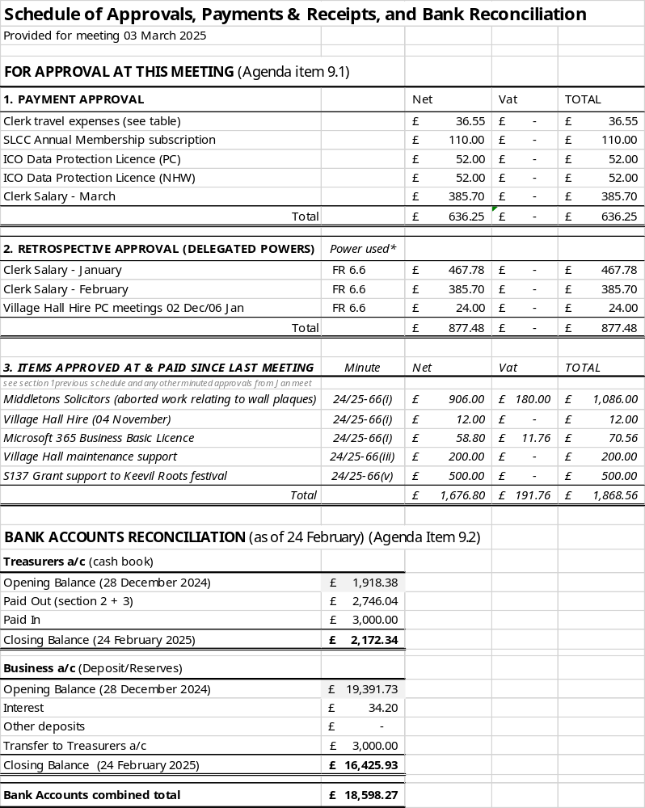
Appendix to 24/25-76(i) - (ii)

