KEEVIL PARISH COUNCIL

MINUTES OF THE ANNUAL MEETING OF THE PARISH COUNCIL
held on Monday 13 May 2024 in Keevil village hall
Present: Councillors Alex Goodwin, Paul Adams, Francis Banfield, Rob Kevan, Rodney Meatyard, Pat Tucker.
In Attendance: 6 members of the public and Cllr Jonathon Seed, Wiltshire Council (WC)
24/25 - 01 Election of Chair:
Cllr Goodwin invited nominations for the Office of Chair (LGA 1972 Sch 12 paras 11 & 27).
Proposed by Cllr Banfield and seconded by Cllr Tucker it was resolved that Cllr Goodwin be appointed Chair for the 2024/2025 municipal year.
24/25 - 02 Declaration of Acceptance of Office: Cllr Goodwin signed the Declaration of Acceptance of Office
24/25 - 03 Apologies for absence: Apologies from Cllr West were noted.
24/25 - 04 Election of Vice-Chair: Cllr Goodwin invited nominations for the Office of Vice-Chair. Proposed by Cllr Kevan and seconded by Cllr Tucker it was resolved that Cllr West be appointed Vice-Chair for the 2024/2025 municipal year.
24/25 - 05 Declaration of Acceptance of Office: The Declaration would be signed postmodem.
24/25 - 06 Declaration of Interest: There were no declarations of interest concerning items on the agenda.
24/25 - 07 Governance and Management Systems 2024/2025
- Register of Interests: It was noted that Councillors entries were up to date.
- Banking: It was agreed that arrangements with Lloyds and current signatories (Cllrs Kevan, Goodwin, Meatyard & West, and the Clerk Sarah Dow) were satisfactory.
- Insurance: It was agreed that arrangements with Community First Insurance were satisfactory.
- Governing documents: Proposed by Cllr Banfield and seconded by Cllr Kevan It was resolved that the following policy documents were reviewed with no change: Code of Conduct, Standing Orders, Complaints Procedure, Habitual Vexatious Complaints Policy, GDPR Policy, General Privacy Notice, Health and Safety Policy, Personnel Committee Terms of Reference, Risk Register;
  - Financial Regulations: following last week’s publication of the new Model Financial Regulations 2024 by the National Association of Local Councils (NALC) it was agreed to review the Parish Council’s Financial Regulations for consideration at the next business meeting;
  - Asset Register: Proposed by Cllr Adams and seconded by Cllr Tucker, it was resolved to adopt the amended Asset Register as presented;
  - Co-option Policy: noting changes in eligibility legislation (Election Act 2022) that came into effect last week, the Co-option Policy would be reviewed for consideration at the next business meeting;
  - Village Planning Policy: as discussed at the previous business meeting, and following today’s announcement of a Planning Service Stakeholder meeting on June 25th at Wiltshire Council’s County Hall offices, it was agreed to discuss the Village Planning Policy at the Annual Parish Community Meeting (APCM) and review at a later date.
- Portfolios, groups & other roles: All current post-holders agreed to continue in their roles (see Appendix).
- The calendar of meetings for 2024/2025 as submitted was confirmed:
Full meetings | Interim meetings eg: for planning (if needed)
13 May 2024 Annual / Ordinary Meeting of the Parish Council | 03 June 2024
01 July 2024 | 05 August 2024
02 September 2024 | 07 October 2024
04 November 2024 | 02 December 2024
06 January 2025 | 03 February 2025
03 March 2025 | 07 April 2025
12 May 2025 Annual Meeting of the Parish Council, followed by Ordinary meeting
24 May 2024 and 23 May 2025 Annual Parish Community Meeting

The meeting closed at 19:38

Signed………………………………………………….……………………….

Dated………………………………………………………….………………..
APPENDIX TO MINUTES OF ANNUAL MEETING 13 MAY 2024
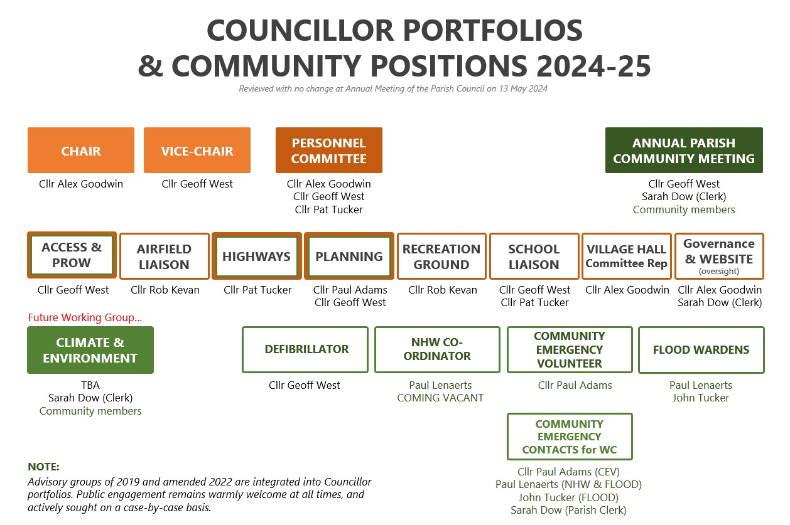
REFERENCE MINUTE ITEM 24-25-7 (v)

