Notice is hereby given of an
ORDINARY MEETING of KEEVIL PARISH COUNCIL
on Monday 4th September 2023 at 7.30pm in the Village Hall
Members of the public are warmly welcomed and will be invited by the Chair to speak about matters they would like the council to note. The meeting may be recorded for minuting purposes.
We continue to follow safe practice guidance: please respect personal space and be sensitive to the precautions of others.
Public Consultation
Meeting Agenda
- Apologies: To receive and note apologies for non-attendance.
- Declaration of Interest: To note any declarations of interest and dispensations concerning agenda items.
- Minutes of previous Meetings: To approve the minutes of the Ordinary Meeting of the Parish Council on 10 July 2023, and the Planning Meeting of 07 August 2023, to be signed by the Chair as a correct record.
- Update from previous minutes not covered elsewhere on this agenda
- Wiltshire Council
  - To receive reports from our Wiltshire Councillor Jonathan Seed and agree any actions required;
  - To note the latest Melksham CPT Community Policing Report.
- Planning Matters
  - To consider the following applications and RESOLVE any responses required:
PL/2023/06788 and PL/2023/06954 (LBC) – East Barton 55 Martins Road: Proposed structural repairs, kitchen extension, bathroom layout improvements, fireplace enhancement, chimney repairs and woodburner installation. Consultation deadline 15 September.
  - To consider applications received after agenda publication if deadlines fall outside meeting schedule;
  - To note submissions of resolved Parish Council consultee responses since last meeting (Appendix 1);
  - To note Wiltshire Council decisions on applications since last meeting (Appendix I);
  - To note the launch of the Wiltshire LOCAL PLAN Consultation and agree further actions;
  - To consider matters relating to land behind the Pump House and agree any actions needed;
  - To note any update relating to the Old Barn site.
- Governance
  - To consider and approve the draft Vexatious Complaints Policy
  - To approve the General Privacy Notice and GDPR Policy with no changes;
  - To receive an update on GDPR training for councillors.
- Annual Parish Community Meeting (APCM) To update on matters agreed not covered elsewhere
  - Poo-Bag scheme
  - Coronation Commemoration Plaque
- D-Day 80: to begin discussion of village plans to commemorate the 80th Anniversary of the Normandy Landings (6 June).
- MEMBER PORTFOLIO REPORTS AND UPDATES:
  - Access & PROW: To receive an update on Rights of Way and countryside access matters, including the old footpath from Butts Lane to the Recreation Ground;
  - Banfield Recreation Ground: To receive an update on matters concerning the playing field, including the replacement springee and in-ground trampoline;
  - Highways and Parish Steward: To receive an update on Highways matters, including:
    - Progress on reconfigured safety railings at the footpath to playing field from Martin's Road
    - Verge damage outside 18a Main Street;
    - Update on stocks held for salt bins in the parish;
  - Keevil Airfield (inc MOD matters & motorsports): to receive an update on communications including the Airfield Games Day - letters of thanks to MOD, and consider funds for future events;
  - Keevil School (including Scarecrow Trail) including an update on communications with school representatives or FOKS;
  - Neighbourhood Watch, Civil Emergency Volunteer, and Defibrillator:
    - To note any updates regarding volunteer vacancies;
    - To receive any update concerning the Defibrillator;
  - Parish Council website: To receive any update on digital matters;
  - Personnel Matters: to receive any updates on staff or payroll matters.
- Financial Matters
  - To receive an update on AGAR 2022-23 Exercise of Public Rights (EOPR) period;
  - To receive schedule of Payments & Receipts for latest period, and RESOLVE cheques/BACS itemised:
Village Hall hire (June 05, July 10 & 25) | 28.00 | - | 28.00
WALC training Feb/March 2023) | 90.00 | 18.00 | 108.00
Inter-parish meeting vitalling (G West) | 18.80 | - | 18.80
SLCC GDPR training x 6 (SO16e payment) | 180.00 | 36.00 | 216.00
Bolt for swing repair (P Lenaerts) (SO16e payment) | 4.51 | - | 4.51
Goalpost fixings (Networld) (SO16e payment) | 22.99 | 7.95 | 31.69
  - To receive current year bank reconciliation to date, and note overall financial position;
  - To note budget performance YTD and payment forecast to November
  - To consider items for 2024-25 Budget and direct the Clerk to prepare a draft for November meeting;
  - To consider any requests for funding.
- Correspondence (not covered elsewhere on the agenda)
- Forthcoming dates to note:
  - Thursday 21 September Parish News deadline for October edition.
  - Wednesday 04 October Local Plan Drop-in session 3-7pm Melksham;
  - Tuesday 10 October Local Plan online session 6.30-8pm (needs registration)
  - Thursday 02 November Next LHFIG meeting (then 8th February 2024);
  - Monday 06 November Next Ordinary Meeting of the Parish Council;
- Any other urgent items arising since publication of agenda, which cannot wait to be considered at the next scheduled Parish Council Meeting (no resolutions can be made).
Close of meeting

CC: Councillor Jonathan Seed (Wiltshire Council) | PCSO Mel Culliford | Tina Fish (Keevil School Administration Officer)
Olivia Adlam (IA) | Dave Bouault, Paul Adams (CEV) | Paul Lenaerts (NHW+Flood team) | John Tucker (Flood team)
Note: Members are reminded that the Council has a general duty to consider the following matters in the exercise of any of its functions: Equal Opportunities in relation to Protected Characteristics | Crime and Disorder | Health and Safety | Human Rights
APPENDIX I: Supporting papers & reference for Councillors
3 | Draft minutes of meetings 10 July and 07 August 2023
5.2 | CPT Community Policing Report TO COME
6.3 | Resolved Consultee responses submitted to Wiltshire Council since last meeting:  10 Aug - PL/2023/05288 67B Martins Road: addition of porch to front, single storey extension to side and rear, loft conversion including roof lights to rear, and steel flue to side. – OBJECT  10 Aug - PL/2023/06234 Small House, 21 Main Street: works to trees in a conservation area. SUPPORT.
6.5 | Wiltshire LOCAL PLAN Consultation – emails of 28 August refer
7.1+7.2 | Draft Vexatious Complaints Policy | General Privacy Notice & GDPR Policy keevilpc.com/governance/
8.1 | Draft minutes of the Annual Parish Community Meeting of 26 May 2023
9 | D-Day 80 Anniversary Guide
11.2+11.3 | Payments & Receipts schedule | Cheques for Approval list | Bank Reconciliation to date TO COME
11.4 | Budget performance and forecast TO COME

APPENDIX II: PLANNING
Response Type: Consultee response submissions require selection from the following options:

OBJECT
SUPPORT
NO OBJECTION
NO OBJECTION SUBJECT TO CONDITION
COMMENT
NO COMMENT
MIXED
CALLED IN BY MEMBER
PETITION OBJECTING
PETITION IN SUPPORT

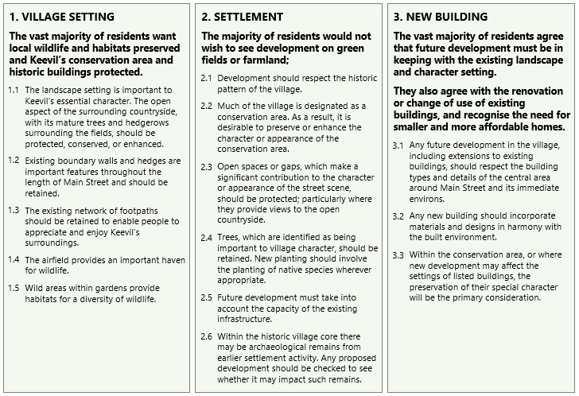
KEEVIL VILLAGE DESIGN POLICY: The following policy statements are primary reference for planning applications in the Parish of Keevil:

