Notice is hereby given of an
ORDINARY MEETING of KEEVIL PARISH COUNCIL
on Monday 10th July 2023 at 7.30pm in the Village Hall
Members of the public are warmly welcomed and will be invited by the Chair to speak about matters they would like the council to note. The meeting may be recorded for minuting purposes.
We continue to follow safe practice guidance: please respect personal space and be sensitive to the precautions of others.
Public Consultation
Meeting Agenda
- Apologies: To receive and note apologies for non-attendance.
- Declaration of Interest: To note any declarations of interest and dispensations concerning agenda items.
- Minutes of previous Meetings: To confirm and sign as a correct record minutes of the Annual Meeting and Ordinary Meeting of the Parish Council on 09 May, and Extraordinary Meeting on 05 June 2023.
- Proper Officer roles
  - To rescind interim proper officer roles and reinstate SO14a (August Minute 22/23–47);
  - To thank Cllr Kevan and Mrs Lewendon for their significant contributions over the last 18 months;
- Update from previous minutes not covered elsewhere on this agenda
- Wiltshire Council
  - To receive reports from our Wiltshire Councillor Jonathan Seed and agree any actions required;
  - To note the Melksham CPT Community Policing Report for May and June 2023.
- Planning Matters
  - To consider the following applications and resolve any responses required:
PL/2023/05095 - Woodhouse Farm, 98 The Strand BA14 6LL: Proposed rural workers dwelling. Consultation deadline 04 August.
  - To consider applications received after agenda publication if deadlines fall outside meeting schedule;
  - To note submissions of resolved Parish Council consultee responses since last meeting (none);
  - To note Wiltshire Council decisions on applications since last meeting (Appendix I);
  - To consider the Wiltshire Design Guide consultation documents and agree further actions;
  - To consider matters relating to land behind the Pump House and agree any actions needed;
  - To note any update relating to the Old Barn site.
- Governance
  - To note correspondence with WC Electoral Services, and resolve actions required to further progress co-option in line with the Co-option Policy;
  - To receive an update on GDPR training for councillors.
- Annual Parish Community Meeting (APCM)
  - To note the draft minutes of the Annual Parish Community Meeting of 26 May 2023;
  - To record the councils thanks to contributing groups and services;
  - To consider follow-up actions to matters agreed at the APCM.
- Neighbouring Parish relationships: to discuss plans for meeting in Keevil on Tuesday 26 July;
- Member Portfolio reports and updates:
  - Access & PROW: To receive an update on matters concerning ROW and countryside access matters;
  - Banfield Recreation Ground: To receive an update on matters concerning the playing field;
  - Highways and Parish Steward: To receive an update on Highways matters and resolve any actions required, including:
    - Progress on access improvements/resurfacing of footpath to playing field from Martin's Road;
    - Dog poo bins and other related initiatives;
  - Keevil Airfield (inc MOD matters & motorsports): to receive an update on communications including any update on proposals for a charity day on the airfield;
  - Keevil School (including Scarecrow Trail) including an update on communications with school representatives or FOKS;
  - Neighbourhood Watch, Civil Emergency Volunteer, and Defibrillator:
    - To note any updates regarding volunteer vacancies;
    - To receive any update on the re-siting of the Defibrillator;
  - Parish Council website: To receive any update on digital matters;
  - Personnel Matters: to receive any updates on staff or payroll matters.
- Financial Matters
  - To receive an update on Annual Governance & Accounting Return (AGAR) 2022-23;
  - To consider the recommendations of the Internal Audit Report of 16 May 2023;
  - To receive schedule of Payments & Receipts for latest period, and approve cheques/BACS itemised:
Village Hall hire (13 April, 26 & 30 May) | 28.00 | - | 28.00
Kitson Electrical (Defibrillator relocation) | 770.27 | - | 770.27
Parish Online Annual Subscription | 50.00 | 10.00 | 60.00
Coronation celebrations (WI S137 grant) | 350.00 | - | 350.00
Internal Auditing fees | 140.00 | - | 140.00
  - To receive current year bank reconciliation to date, and note overall financial position;
  - To note budget performance YTD and payment forecast to September,
  - For completeness, to retrospectively approve annual insurance of £968.28 (2nd of 3 year contract), and adjust the insurance budget by +£103.74 for Premium Tax (May minute 23/24-19(v);
  - To consider any requests for funding FY 2023-24.
- Correspondence (not covered elsewhere on the agenda)
- Forthcoming dates to note:
  - Tuesday 25 July Cheese & wine evening with neighbouring Parish Councils
  - Thursday 27 July Next LHFIG meeting (then 2nd November, 8th February 2024);
  - Sunday 30 July Wiltshire Design Guide consultation ends;
  - Monday 07 August (Provisional) Extraordinary Meeting of the Parish Council;
  - Thursday 24 August Parish News deadline for September edition.
- Any other urgent items arising since publication of agenda, which cannot wait to be considered at the next scheduled Parish Council Meeting (no resolutions can be made).
Close of meeting

CC: Councillor Jonathan Seed (Wiltshire Council) | PCSO Mel Culliford
Tina Fish (Keevil School Administration Officer)
Olivia Adlam (Internal Auditor)
David Bouault (Community Emergency Volunteer) | Paul Lenaerts (NHW & Flood Response) | John Tucker (Flood Response)
APPENDIX I: Supporting papers & reference for Councillors
3 | Draft minutes of meetings 09 May, and 05 June 2023
6.3 | Awaiting CPT reports
7.4 | - 09 May PL/2023/00776: for access track and relocation of gateway access at entranceway & field behind Pump House/82A Main Street – WC APPROVE w/conditions (Parish Council objected)  - 06 June PL/2023/01371 and PL/2023/01546 (LBC) Pinkney House 84 Keevil - conversion of domestic barn/outbuilding to domestic annexe – WC APPROVE w/ conditions.
7.5 | Wiltshire Design Guide consultation – email of 03 July refers
9.1 | Draft minutes of APCM 26 May 2023
12.2 | Internal Auditor Report (Olivia Adlam)
12.3, 12.4 | Payments & Receipts schedule | Cheques for Approval list | Bank Reconciliation to date
12.5 | Budget performance and forecast

APPENDIX II: PLANNING
Consultee response submissions require selection of Response Type from the following options:

OBJECT
SUPPORT
NO OBJECTION
NO OBJECTION SUBJECT TO CONDITION
COMMENT
NO COMMENT
MIXED
CALLED IN BY MEMBER
PETITION OBJECTING
PETITION IN SUPPORT

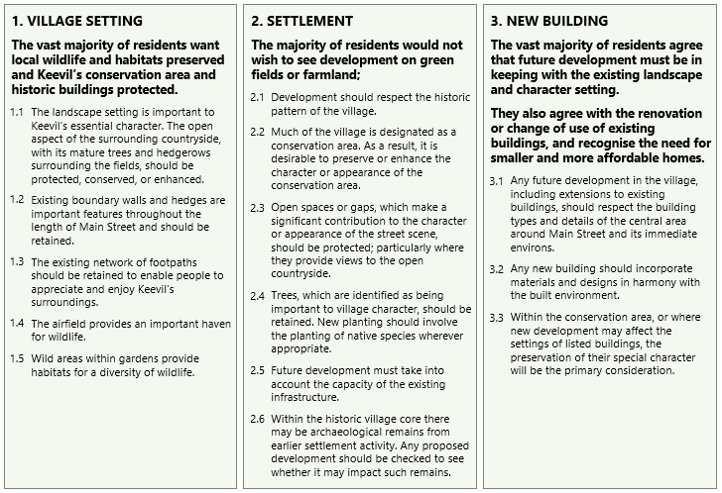
KEEVIL VILLAGE DESIGN POLICY: The following policy statements are primary reference for planning applications in the Parish of Keevil:

Note: Members are reminded that the Council has a general duty to consider the following matters in the exercise of any of its functions: Equal Opportunities in relation to Protected Characteristics | Crime and Disorder | Health and Safety | Human Rights

