Notice is hereby given of a
Ordinary Meeting of the Parish Council
On Monday 6th March 2023 at 7.30pm in the Village Hall

Members of the public are warmly welcomed and will be invited by the Chair to speak about matters they would like the council to note. The meeting may be recorded for minuting purposes.
We continue to follow safe practice guidance to ensure ventilation. Please sanitise hands on arrival, and respect personal space.

Public Consultation

Meeting Agenda

- Apologies: To receive and note apologies for non-attendance.
- Declaration of Interest: To note any declarations of interest and dispensations concerning agenda items.
- Minutes of previous Meetings: To confirm and sign as a correct record minutes of the Ordinary Meeting of the Parish Council on January 9th and Planning meeting on February 13th 2023.
- Update from previous minutes not covered elsewhere on this agenda
- Wiltshire Council
  - To receive reports from Cllr Jonathan Seed, including update on HMA changes and rural policing;
  - To agree any actions required by the Parish Council as a result of his report/updates;
  - To note the Melksham CPT Community Policing Report for February.
- Planning Matters
  - To consider the following applications and resolve any responses required:
PL/2023/00859: Elmleaze Farm BA14 6NF - Change of use 2-bed holiday let to dwelling (C3 use class);
PL/2023/00776: Entranceway & field behind Pump House/82A Main Street - Reinstatement of earlier access track and relocation of gateway access from the highway;
PL/2023/01535: East Barton, 55 Martins Road BA14 6NA - works to trees in a conservation area; Fell Row of 5 Leylandii that have outgrown position causing structural damage to GII listed structure;
PL/2023/01371 and PL/2023/01546 (LBC) Pinkney House 84 Keevil BA14 6NH - conversion of domestic barn/outbuilding to domestic annexe
  - To consider applications received after agenda publication if deadlines fall outside meeting schedule;
  - To note submissions of resolved Parish Council consultee responses since last meeting (Appendix I)
  - To note Wiltshire Council decisions on applications since last meeting (Appendix I)
- Governance
  - To receive an update on GDPR training for councillors;
  - To approve the updated draft co-option policy;
  - To consider any developments in matters relating to FOI request and resolve any actions required;
  - To note any updates regarding the NALC Local Council Awards Scheme (LCAS).
- The King’s Coronation 2023: to discuss commemorative events and other ideas;
- Annual Parish Community Meeting 2023: to discuss actions and format for 2023 event.
- Neighbouring-Parish relationships: to receive an update on proposal for a next meeting
- Member Portfolio reports and updates:
  - Personnel Matters: to receive any updates on staff or payroll matters;
  - Keevil School (including Scarecrow Trail): to receive an update on communications with school representatives or FOKS.
  - Keevil Airfield (including MOD matters, Watchkeeper airspace change proposals, motorsports): to receive an update on any general communications concerning airfield matters, including: -
    - Suggestions for possible charity day on the airfield.
  - Highways and Parish Steward: To receive an update on general Highways matters, including;
    - CIL fund/LFHIG project: to note progress for access improvements and resurfacing of the footpath between the playing field and Martin's Road;
    - To receive an update regarding salt bins in the parish
    - To receive an update of WC response to Flood Warden report of broken drain cover near Towmead Lane, note correspondence regarding bus parking, and resolve any further actions;
    - To consider correspondence regarding dog poo bins and resolve any action required.
    - To consider correspondence regarding removal of hedgerow between The Strand & Great Hinton, and resolve any action required;
    - To discuss possibility of ‘Quiet Lane’ designation (Buzzley Bottom) and any further actions.
  - Banfield Recreation Ground: To receive an update on general matters concerning the playing field;
    - To consider any recommendations on replacement of equipment;
    - To note agreed requests for use of playing field for events 23 March & 17 June 2023.
  - Parish Council website: To receive any update on digital matters.
  - Neighbourhood Watch, Civil Emergency Volunteer, and Defibrillator:
    - To note any updates regarding volunteer vacancies;
    - To receive an update on proposals to re-site the Defibrillator.
  - Advisory Groups:
    - To note any updates from: Accessibility & ROW | Highways | Conservation & Environment;
    - To hear from members in attendance at WALC Countryside Access event;
    - To note correspondence regarding electric fence blocking footpath, and other access issues, and agree any actions required.
- Financial Matters
  - To note any update regarding membership of the Internal Auditors Forum;
  - To consider advice of Internal Auditor & RFO, and resolve a preferred approach of AGAR Part 2 Certificate of Exemption for FY 2022-23;
  - To receive schedule of Payments & Receipts for latest period, and approve cheques/BACS itemised:
Village Hall hire (9 Jan) £ 12.00
Training (1 x SLCC/GDPR) £ 30.00
SLCC Membership 2023-24 £ 80.00
GDPR/ICO licences (KPC & NHW) 2023-24 £ 80.00
ROW village map pack wallets £ 92.00
  - To receive current year bank reconciliation to date, and note overall financial position;
  - To review current year performance to budget and note payment forecast to Year End (March 31);
  - To note any correspondence further to S137 donations made in January ;
  - To consider any further information arising regarding requests for funding in FY 2023-24;
  - To note submission of the precept for FY 2023-24 to Wiltshire Council.
- Correspondence (not covered elsewhere on the agenda)
- Forthcoming dates to note:
  - Weds 8th March: Melksham Area Board, 7pm, Melksham Community Campus Library
  - Thurs 23rd March: Parish News deadline for April edition;
  - Tues 9th May: Next LHFIG meeting ( then 27th July, 2nd November, 8th February 2024;
  - Tues 9th May: Next Ordinary meeting of the Parish Council will be the Annual Meeting of the Parish Council at 7.30pm, followed by the business meeting;
  - Fri 26th May: Annual Parish Community Meeting
- Any other urgent items arising since publication of agenda, which cannot wait to be considered at the next scheduled Parish Council Meeting (no resolutions can be made).
Close of meeting

APPENDIX I Supporting papers & reference for Councillors
3 | Draft minutes of Ordinary Meeting January 09 and Planning meeting February 13 2023
4 | Email of 23 Jan refers (Training/networking calendar from WALC)
5.1 | Emails of 20 January and 01 February refer;
6.3 | Resolved or delegated Consultee responses submitted to Wiltshire Council since last meeting:  - 14 Feb - PL/2022/09841 - replacement windows at 80 Main Street – NO OBJECTION;  - 09 Jan - PL/2023/00009 – LBC remedial works at Baldham House, Baldham – SUPPORT;
6.4 | Wiltshire Council decisions on planning application since last meeting:  - 2 Feb - PL/2023/00009 – LBC remedial works at Baldham House – APPROVE W/CONDITIONS;  - 12 Jan - PL/2022/06831 – Roofing works & solar panels at 30 Pyatts Corner BA14 6LY – WITHDRAWN BY APPLICANT
7.2 | Updated draft co-option policy –
7.3 | Briefing, and email of 01 February refers
8 | Coronation page on village website https://keevilvillage.com/whats-on/coronation-2023/
11.4.3 | Email of 25 February refers
11.4.4 | Emails of 02 & 03 February refer, and location map in email of 07 February
11.4.5 | Emails and briefing of 05 February refer
11.5.2 | Email of 16 February refers
11.8.3 | Email of 25 February refers
12.3, 12.4 | Schedule of Payments & Receipts | List of Cheques for Approval | Bank Reconciliation to date
12.5 | Budget performance and forecast

CC: Councillor Jonathan Seed (Wiltshire Council)
Olivia Adlam (Internal Auditor)
Barbara Lewendon (Minute Secretary
Tina Fish (Keevil School Administration Officer)
PCSO Mel Culliford
David Bouault (Community Emergency Volunteer)
Paul Lenaerts (NHW and Community Flood Response team)

Note: Members are reminded that the Council has a general duty to consider the following matters in the exercise of any of its functions: Equal Opportunities in relation to Protected Characteristics | Crime and Disorder | Health and Safety | Human Rights
APPENDIX II: Planning
PARISH COUNCIL CONSULTEE RESPONSES TO PLANNING APPLICATIONS
Consultee response submissions are made via the Wiltshire Council Planning Portal. Response Type must be selected from a drop-down menu as follows; supporting narrative comments and files may also be added:
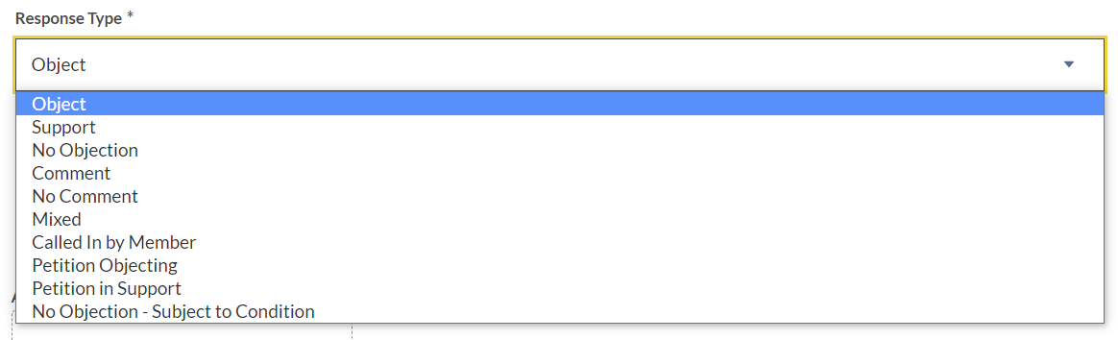
KEEVIL VILLAGE DESIGN POLICY 2022
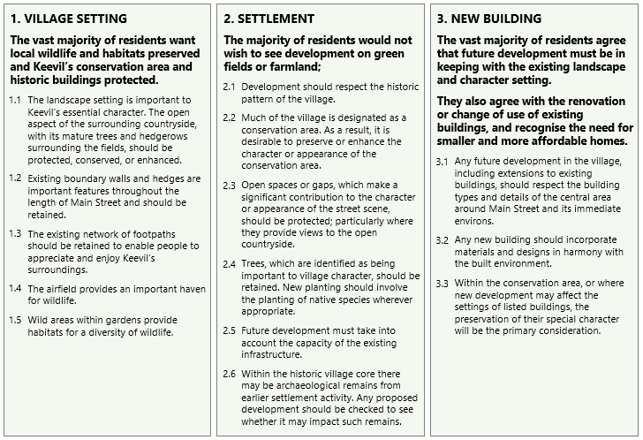
The following policy statements are considered primary supplementary reference for all planning applications in the Parish of Keevil. The contents of the Village Design Statement remain a material source of reference.

