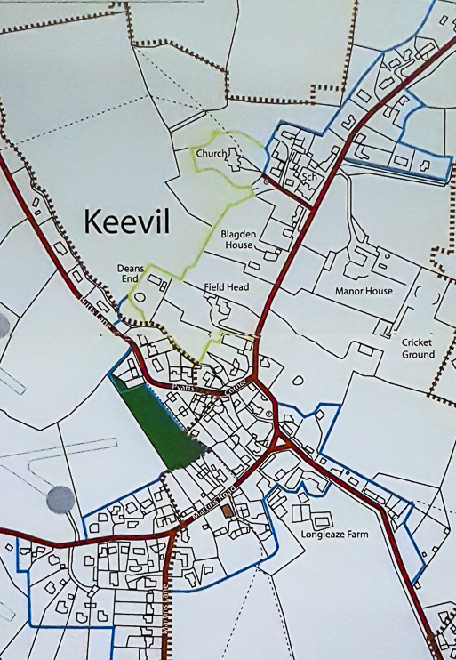
Keevil W.I. Advent Trail
21
24
23
22
20
19
18
17
16
15
14
13
12
11
10
9
8
7
6
5
4
21
32
1

